Complete Grammar Overview:
Nouns:
A noun can be nominative or accusative. Nominative means that it does the action. Accusative means that it receives the action.
Caecilius canem audit. Caecilius hears the dog.
canis Caecilium videt. The dog sees Caecilius.
Observe how the spelling changes for each noun depending on if it performs or receives the action.

Nouns can also be singular or plural. Singular means that there is only one of them. Plural means that there is more than one.
servus cenam parat. The slave prepares the food.
servi cenam parant. The slaves prepare the food.

Singulars and Plurals occur in both the Nominative and Accusative cases.
canis servum videt. The dog sees the slave.
canis servos videt. The dog sees the slaves.

Here is a chart that shows all the spelling changes for the nouns
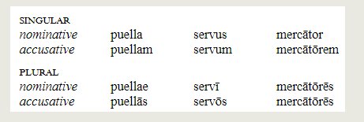

Verbs:
Verbs tell you a lot in Latin. They tell you what happens (the definition), who does it (the person), and when it happens (the tense).
What we know right now about person
The ending of a verb changes based on who does the action. Example:
Caecilius cantat Caecilius sings
Ego canto I sing
Tu cantas you sing
servi cantant the slaves sing

Here is a complete chart of the persons
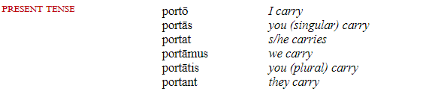

The other thing the verbs show is when, and we call this tense.
Servi ambulant the slaves walk
Servi ambulabant the slaves were walking
Servi ambulaverunt the slaves walked

We call the “was/were” verbs with a -ba- the imperfect tense. We call the “-ed” verbs with a -v/s/u/x- the perfect tense
Here is a complete chart of the tenses.
